No, the standard Network Time Protocol (NTP) is not encrypted and lacks built-in security features, making it vulnerable to man-in-the-middle (MITM) attacks where an attacker can inject false time data. To address this, the Network Time Security (NTS) protocol was developed, which adds authentication and encryption layers to NTP communication using Transport Layer Security (TLS) on a separate TCP port (4460) to protect against these vulnerabilities.
Why NTP is Unsafe
- Lack of Encryption:
The primary reason NTP is considered insecure is that it transmits time data and cryptographic information in plain text, allowing attackers to intercept and manipulate it.
- Vulnerability to Attacks:
Without security, NTP is susceptible to:
  - Man-in-the-Middle (MITM) attacks: Attackers can insert themselves between the client and server to feed a client with incorrect time data.
  - Spoofing: An attacker can pose as a legitimate NTP server to trick clients.
  - Replay attacks: Manipulated packets can be resent to a client to mislead its timekeeping.
Network Time Security (NTS): The Solution
- Enhances NTP Security:
NTS adds a security layer to the existing NTP protocol.
- Uses TLS/SSL:
It leverages TLS (Transport Layer Security) to establish secure connections for key exchange and packet authentication.
- Key Establishment (NTS-KE):
NTS uses NTS-KE, a protocol for automatically creating encryption keys between the server and clients.
- Cookie-Based Security:
NTS servers issue encrypted cookies to clients, which contain the keys needed to authenticate NTP packets.
- Improved Privacy:
Each new server response includes a fresh cookie, which prevents passive observers from tracking clients across different networks.
- Deployment:
NTS can be used with the ntpd-rs implementation, a more secure alternative to traditional NTP clients.

See https://www.scip.ch/?labs.20221117

slido

NTS
“National Alliance of Russian Solidarists”
“Null-terminated string”
“Nature Technology Systems”
“Network Time Security“
"Network trust service"
“National Ticketing Solution”
“Nevada Test Site”

"Network trust link service"

https://commadot.com/wtf-per-minute/

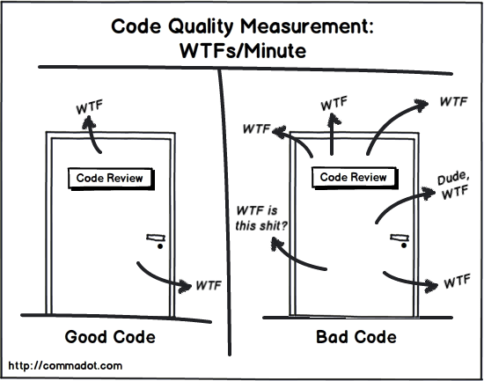

https://www.commitstrip.com/en/2016/08/25/a-very-comprehensive-and-precise-spec/

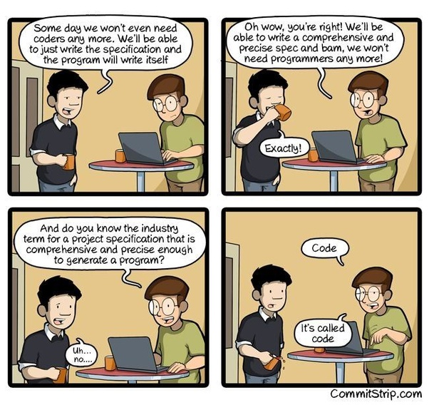

a) ist spezifiziert wie der code auf falsche zeit reagiert
b) ist gecodet wie spezifiziert
c) gerade bei distributed services können zeitdivergenzen katastrophal sein

you may want to leave this less important presentation now if you are not sure that this topic is handled securely in your systems

typical problems in ops are correct configurations (dev / test / prod – then changes) and also state of services

Test for availability of services and plausability of configuration at startup or specific situations
Maybe even make dev & test services discernible by behaviour to avoid mistakes
Checks go into lib or a copied & pasted and can be reused. Checks have a limited from within the system perspective.

Production

What can go right
Real problem in the distributed system is handled as specified
What can go wrong
- Something is is not handled as specified or is not specified
- by chance (wtf-per-minute, ...)
- by choice (bad actor)

Example scenario

Control Board that shows aggregated information from many systems and allows human intervention at least in emergency, maybe even acts autonomously.
Safety critical. Needs up to date / timestamped information

What would you say in a code review when you see a (new) checkTimeSystem() call (from the system checks lib) in the code that oversees the production.

You definitely would check if the tests are green.
Would you check for other places where the code is used?
Would you check the (not existing) docs?

Now there is a problem (maybe someone messes) with NTP (Network Time Protocol) in a (preferably) is not clearly traceable system wide, maybe only triggers the checks.

Having checks implemented in the “right “places can render the system unusable and cause damage/losses.

Modified Marc Elsberg “Blackout” Szenario


with vibe coding there is no deliberate detailed spec
even with professional managed software there is often no real deliberate and detailed enough spec

Approaches
is there code that does things that are not specified

With Firmware these questions become harder

What we built / implemented
- Spec
- Example control board firmware
- with startup test
- with additional not specified test
- the test will not be real as we will not set up a multi system network in this short hackathon
- the test could trigger one spoofed time (time jump, time not plausible, ...)

- we do not handle the firmware extraction but assume that that the system provider is bound by contract to also provide the firmware files (at least, better would be source)

Workflow
1) Decompile Firmware to assembler, maybe c or meta code or use source code
1a) Maybe ( if possible) diff

2a) Ask llm if it sees code that is not warranted by the spec
2b) Ask llm if it sees code that would be needed by the spec

3a) generate warnings,
3b) help preparing reviews

Lessons
Security is complex, did you know “Network Time Security“
For secure systems a detailed spec is important.
A good & detailed spec could be helpful at vibe/prompt coding
Option: use the prompts plus the code to generate human readable specification.
Should be good for back and forth checks. Not evaluated in this hackathon.
A good detailed spec definitely helps at code review an analysis

